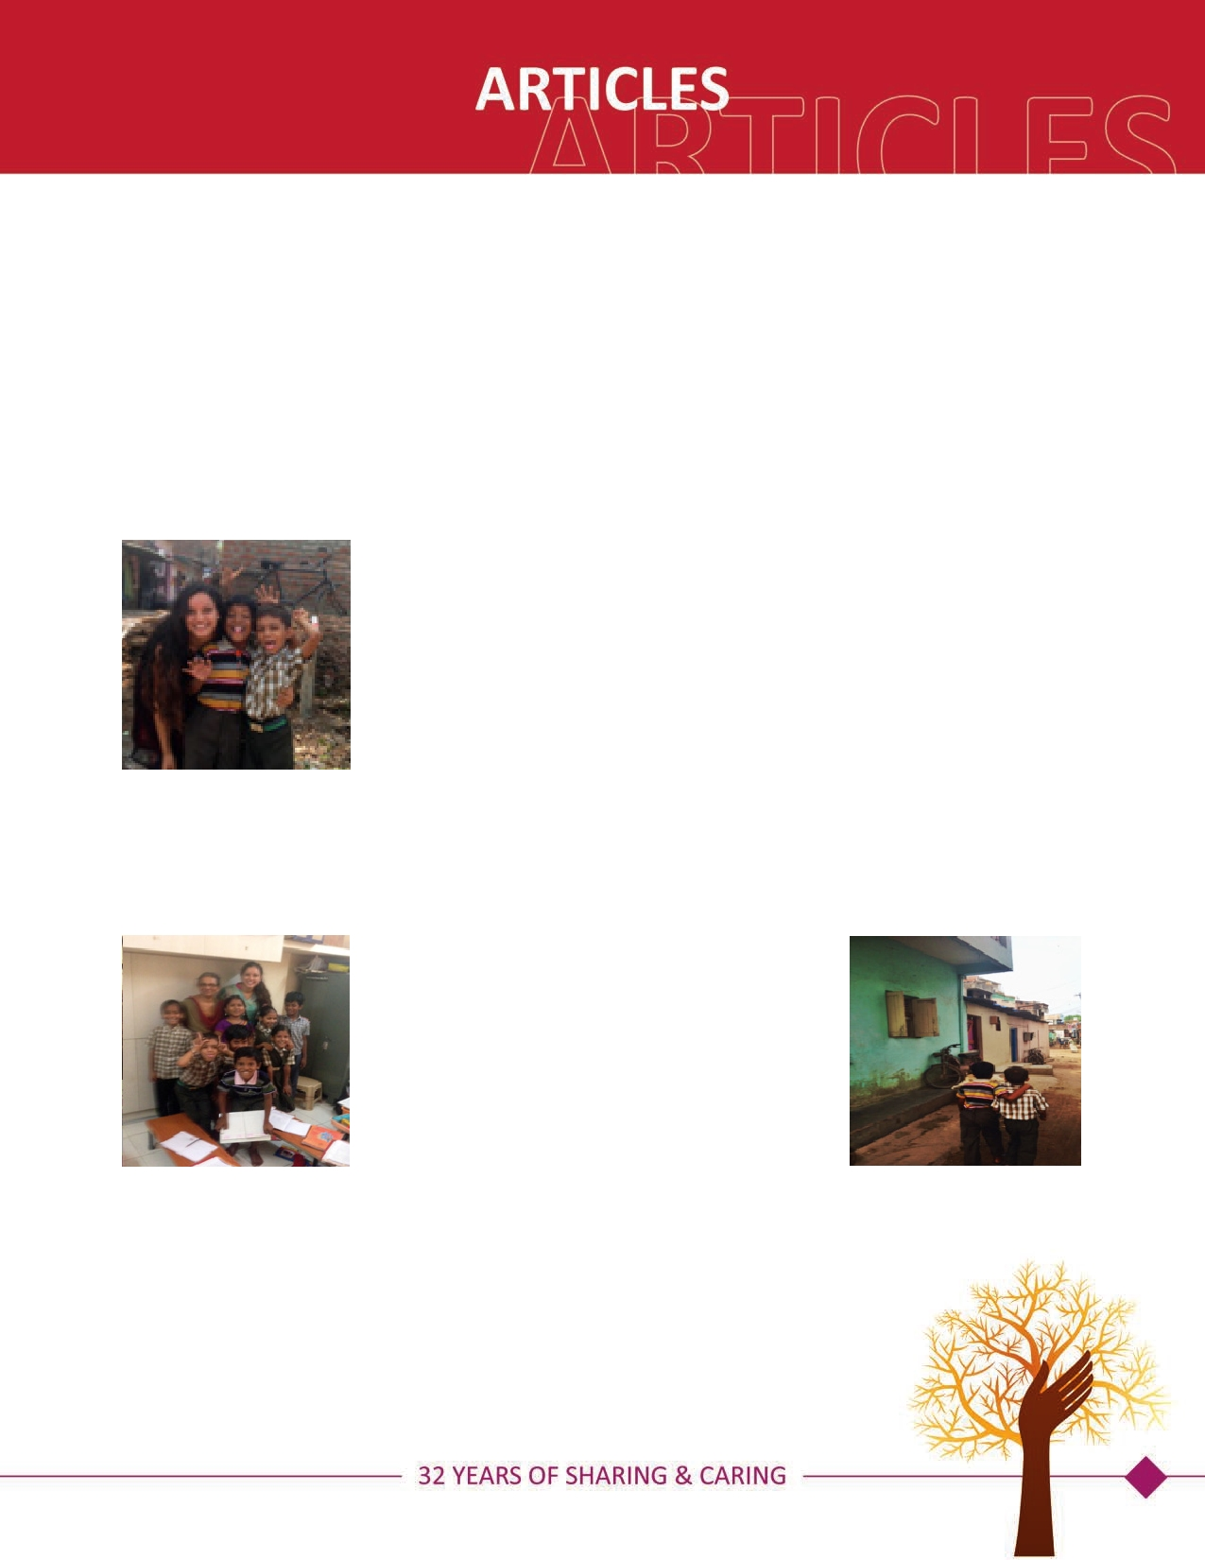CHANGING THE WORLD, ONE SLUM AT A TIME
-by Charmie Mehta

Charmie Mehta volunteered for 10 days at the Koshish-Milap trust, Vadodara, India. This trust was founded by Dr. Kishor Mistry,
Dr. Varsha Shah and three other trustee. Kishor and Varsha returned to india to give back to the motherland after 21 years of stay in
USA. Share and Care Foundation is proud to support their work during the last three years.

Within the MujMahuda Slums lie the efforts of a group of perseverant people with one united

goal in mind- to educate, heal, and better the lives of those who do not have the opportunities

to have access to those things. The children attending the well-kept and organized school are

about all subjects. The most important aspect in their eyes, as explained by Dr. Varsha Shah, is

truly able to focus on all aspects of their education- including proper manners and learning

that "no matter the age or ability of the student, they must be taught the basics of all the sub-

jects before being able to move on. The skills learned in the elementary level prove to be vital

to move on to other, more advanced skills." This approach is an effective way to close any gaps

in learning for the children. In the particular classroom where I spent most of my time, I saw

of just moving along the lessons or taking too much time on a particular one, the teachers gave

certain students excelling in subjects those others had difficulties with and vice versa. Instead
different levels of the same lesson (differential instruction) to each student, so that no student

felt bored or rushed. Also, if any particular student was having trouble with a certain lesson, he or she worked at the desk right next to the teacher so she could constantly be checking on the child’s work. One student in our class, Roshni, was extremely skilled in language skills, but behind in math. Whenever it was time for math, her confidence would go down and she would speak softly. She mainly had trouble understanding the concept “how much difference” between two numbers.

After one month of struggle, Dr. Varsha Shah finally found

a breakthrough. She showed Roshni two sticks of different

sister. Roshni knew one was taller, but not by how much. So

sizes and told them they were the heights of her and her

Dr. Varsha asked her how much taller was one sister than

two sticks- therefore realizing she had to "take out the small

the other, and Roshni pointed to the difference between the

ni's confidence and love for math increase because of an in-

from the big" to find the difference. I myself got to see Rosh-

her own willingness to learn and overcome her weakness.

tense help from someone who could patiently guide her, and

mediately capitalized for advancing education, as seen in From a
broader perspective, the donations received immediately capitalized for advancing education, as seen in cases where seven students were able to catch up two grades and two students could catch up three grades of academic material in one year with intensive support. Ten students were struggling in a private school. However, they started getting B grades through the support provided and some of the slum school’s sponsored students in private schools are rank-holders in their class! Other success stories include: eight students who left our class last year have come back, and their average score on the annual exam was 88%.

67

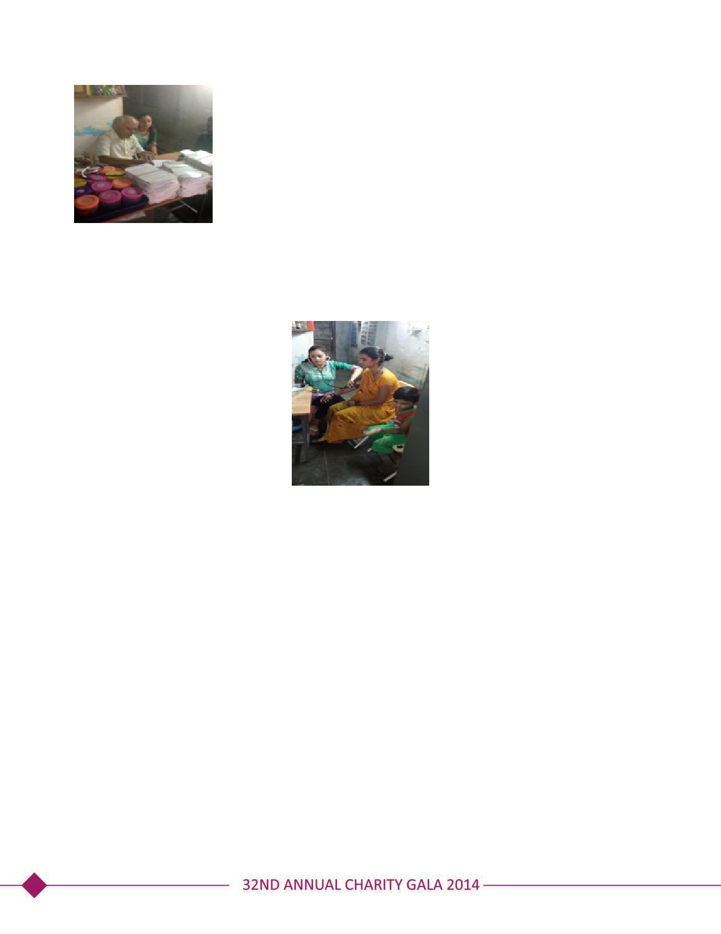

But a general education isn’t all this community is receiving. In the evenings, from 4 pm to 8
pm, a medical education can be received as well. Dr. Kishor Mistry emphasizes preventive
measures like vaccination, a healthy lifestyle (hygiene, nutrition), preventing addictions (Gut-
ka, smoking, alcohol), reducing the risk of fungal diseases, and more. He dispenses medicines
for the most common illnesses including cold, malaria, bacterial infections, skin diseases, pain,
acidity, diabetes, hypertension, asthma/COPD, depression, gastroenteritis, ear/eye infections,
etc., as well as shots for Vitamin B Complex and Malaria. The best part is that the clinic buys
the medicines wholesale and can sell them to the slum people at 30% of the usual cost, or
even less, depending on how poor the individual and his/her family is. Also the consultation is
always FREE. I myself saw this doctor-patient trust when a young girl of around 18 years
came into the clinic and openly talked with the doctor about her abortion. She had bought abortion pills from an outside store but was still bleeding in the uterus. She was advised that her pregnancy may not have been fully terminated and she needed to get a sonography to confirm it so that her situation can be better understood. Outside of the medical advice he gives, every person that comes in to the clinic is encouraged by him to go to school regularly so that they can move forward in their lives. This way, the clinic ties directly into education also.

Last, but definitely not the least, is NOVOI. Everyday there are people working on the online database updating NGOs and their

of Indian NGOs and funding agencies, to develop online e-library of the published literature for NGOs, and facilitate an exchange

create a platform for sharing their experiences. To achieve this, a separate website is being developed to compile the data-base

Overall, my time here opened my eyes to the true misfortune of the slum community. But, it also gave me much hope for the

of experiences through electronic journal, meetings, training, and central resource facility.
Overall, my time here opened my eyes to the true misfortune of the slum community. But, it also gave me much hope for the future of these families and their coming generations. I developed a tight bond with the children in my class: they would visit me in the clinic later in the evenings, I would go to see where they lived, and understand more about their strengths and weaknesses in and out of the education they were receiving. All the children were so excited to truly learn, showing that, with the right approach, they can do great things. The clinic also allowed me to develop my own patient relationships built on trust and it was a wonderful opportunity to get to know everyone in the MujMahuda Slums. I’m humbled to have been able to help, teach, and heal people whose hearts are full of so much love and eagerness to educate themselves and better their lives.

Respect for ourselves guides our morals,
respect for others guides our manners.

